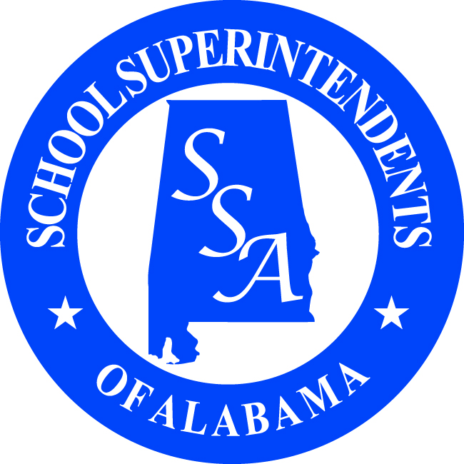

NEWS IN EDUCATION Contact: Janet McCain
FOR IMMEDIATE RELEASE or Dr. Eric Mackey Phone: (334) 262-0014
or 1-877-269-0014

SSA Awards $14,000 in Scholarships
To Students and Administrators for 2012

Montgomery, AL., April 23, 2012 –The School Superintendents of Alabama (SSA) is proud to announce the high school graduating seniors who are recipients of $9,000 in SSA Student Scholarships and the teachers and administrators who are recipients of $4,000 in SSA Administrator Scholarships for 2012.
Congratulations to the recipients of SSA’s student scholarships who all intend to pursue a bachelor’s degree in education. The student scholarship recipients include SSA’s District one: Tyler Montana Prescott from Thomasville High School in the Thomasville City School System, and he plans to attend the University of West Alabama; SSA’s District two recipient: Amanda Proper from Prattville High School in the Autauga County School System, who plans to attend the University of Alabama in Birmingham; SSA’s District three recipient: KhaTara Lott from Headland High School in the Henry County School System, and he plans to attend Troy University; SSA’s District four recipient: Danielle Koretz from Central High School in the Phenix City School System, plans to attend Huntingdon College; SSA’s District five recipient: Alexandrea (Ally) Reed from Fultondale High School in the Jefferson County School System, plans to attend the University of Montevallo; SSA’s District six recipient: Christopher Strott from Piedmont High School in the Piedmont City School System, plans to attend Jacksonville State University; SSA’s District seven recipient: Amelia Chastine from Hillcrest High School in the Tuscaloosa County School System, plans to attend the University of Alabama; SSA’s District eight recipient: Niels Paetow from Muscle Shoals High School in the Muscle Shoals School System, plans to attend Concordia University; and SSA’s District nine recipient: Elizabeth Catherine Epperson from Albertville High School in the Albertville City School System, plans to attend Snead State Community College.
This is the fourth year SSA’s Student Scholarship recipients have been named by the Superintendents who were district finalists of the SSA/Classworks Superintendent of the Year Award. Those Superintendents for 2012 included Dr. Vic Atkison, Thomasville City; Mr. Greg Faulkner, Autauga County; Mr. Dennis Coe, Henry County; Dr. Larry DiChiara, Phenix City; Dr. Phil Hammonds, Jefferson County; Mr. Matt Akin, Piedmont City; Dr. Frank Costanza, Tuscaloosa County; Dr. Jeff Wooten, Muscle Shoals City; and Dr. Ric Ayer, Albertville City.
Also, since our District 1 Superintendent of the Year district finalist for 2011, Dr. Wayne Vickers, was leading a new school system last year and did not have a graduating class until this year, SSA is now able to award his recipient, Emil Harris from Saraland High School in the Saraland City School System, and he plans to attend Mile’s College.
Congratulations to SSA’s four administrator scholarship recipients who are all pursuing higher degrees in school administration. These teachers, counselors, or practicing administrators will be seeking their higher degrees at the M.S./M.A., AA/Ed.S., or Ed.D/Ph.D. levels. The four recipients selected to receive scholarships include Dana M. Griggs, a teacher at Carroll High School Career Center for the Ozark City School System, who is pursuing her Doctorate in Educational Leadership at Auburn University; AnnaKay Holland, a Business Education teacher at the Russellville High School in the Russellville City School System, who plans to obtain a doctoral degree from the University of Alabama; Tabitha G. Owens, a Special Education teacher at Coosa Central High School in the Coosa County School System, is currently pursuing her M.A. in Educational Leadership at the University of Montevallo; and Debbie T. Reetz, a Reading Coach at Richland Elementary School in the Auburn City School System, plans to pursue a graduate degree in Educational Administration and Leadership. These SSA Administrative Scholarship recipients will be formally presented with their scholarship checks by their respective Superintendent during an upcoming school event or Board meeting. SSA’s Administrator Scholarship applications were scored by SSA’s Awards and Scholarships Committee which is chaired by Dr. Jeff Langham, Elmore County School Superintendent.
“The major purpose of SSA is to promote high quality public education in every community throughout the state. These scholarships reinforce that mission by helping these high-achieving students become teachers and helping our leaders go back to graduate school, too. We are proud of these recipients and their commitment to quality in our schools. It takes investment to make good things happen, and this is an investment we are proud to make,” said Dr. Eric Mackey, SSA Executive Director.

--- X X X ---

